WOMBEYAN

Wombeyan Caves said to have been discovered in 1828 by the then Surveyor-General, John Oxley. Although the caves did not attract the same attention as at Jenolan, the area was reserved by the Government of the day in 1865. It has a number of well-decorated caves and is a popular tourist site. Members of the Sydney Speleological Society (Dyson et al. 1982) comprehensively described the area in a very useful book.

1. KERRY SERIES 26 [n.l.1905]

Ph Charles Kerry
Pu Kerry & Co.
Pr In Germany by collotype
F Photograph with title in wide white margin at lower edge (if V) or R.H. edge (if
H). We have only seen one style of back. However, titles appear both with (A) and
without (B) quotation marks. There are also several distinct (although sometimes
difficult to distinguish) patterns in the relative location of the title and series
imprint.

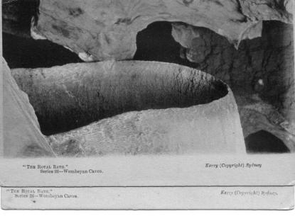
We distinguish these below by adding a letter to the serial number and where
cards have been readily available, we have indicated by underlining the letter
beneath which the 'S' of Series is located. See also illustration below.

1A 1A.1a "The Museum." [Kooringa Cave] H [pm.3 Mar.1906]
1A.2a "The Royal Bath." H [pm. 12 Jun 1906, 17 Sep.1906]
1A.2b "The Royal Bath." H [20 Nov 1908]
1A.3 "Mermaid's Home." H [pm.3 Mar.1906]
1A.4a "The Church." [now Victoria Arch] H
1A.4b "The Church." H [now Victoria Arch] [pm.18 Jul.1906]
1A.5a "The Sentinel." V [pm.13 Jul.1906]
1A.5b "The Sentinel." V [pm.11 Dec.1913]
1A.6a "Lot's Wife." [Wollondilly Cave] V [pm.26 Jun.1906]
(This card is titled as Series 25, but this is clearly a typographic error: Kerry's
series 25 is entitled 'Studies from Life'. We also have one example printed
on exceptionally lightweight card.)
1A.6b "Lot's Wife." [Wollondilly Cave] V
1A.7 "The Mantel Drape." [Kooringa Cave] V
1A.9a "The Pantheon." [Wollondilly Cave] V
(We have one copy overprinted 'For T.A.F. Darker, Brisbane-
Street, Ipswich. pm.9 Jan.1906)
SAME [6 Mar 1906]
1A.9a "The Pantheon." [Wollondilly Cave] V
1A.10 "Jacob's Ladder." [Junction Cave] V [pm., in London, 26 Jan.1906]
1A.11a "Fairies' Grotto." [Mulwaree Cave] H
1A.11b "Fairies' Grotto." [Mulwaree Cave] H

1B 1B.1 The Museum. [Kooringa Cave] H
1B.3 Mermaid's Home. H [pm.23 Jan.1907
1B.7 The Mantel Drape [Kooringa Cave] V [pm.6 Oct.1908]
1B.8.a Shawls. [Wollondilly Cave] V [pm.3 Mar.1906]
1B.8.b Shawls. [Wollondilly Cave] V [pm.15 Dec.1911]
1B.12.a The Long Corridor. [Wollondilly Cave] H
1B.12.b The Long Corridor. [Wollondilly Cave] H

2. PHILCO SERIES [n.l. 1907]

Pu Philco Publishing Co., London (Byatt 1978, p. 199)
F Photograph with title and imprint (Philco Series 1041D) in lower edge of all-
round margin. Printed in both B & W (A) and colour (B).

2A.1 Wombeyan Caves Road, N.S.W. H (Depicts a sandstone tunnel which was cut
through a ridge in 1899 to facilitate access to the caves)
2B.1 Wombeyan Caves Road, N.S.W. H

3. GRAPHIC SERIES [n.l. 1907]

Pu Collins Bros. & Co. (Cook 1986, p. 132)
Pr In Great Britain
F Printed in bluish-green with title in lower margin.
(see also Jenolan 36)

3.1 "The Mantle," Wombeyan Caves, N.S.W. H
3.2 "The Throne," Wombeyan Caves, N.S.W. H [pm.30 Apr.1907]

4. N.S.W. GOVERNMENT TOURIST BUREAU - LIMESTONE CAVES SERIES [n.l. 1913]

Pu N.S.W. Government Tourist Bureau
F Printed in purple (A), or B & W (B) half-tone with title superimposed
on view. This is part of same series as Jenolan 40.

4A.1 Lot's Wife and Cockatoo/Wollondilly Cave, Wombeyan V
4A.2 Mystery Chamber/Wollondilly Cave, Wombeyan H
4A.3 The Throne,/Kooringa Cave, Wombeyan
4A.4 Archway/On the road to Wombeyan Caves V
4A.5 Judgement Seat/ Figtree Cave, Wombeyan
4A.7 Victoria Arch/Wombeyan Caves V

4B.3 The Throne / Kooringa Cave, Wombeyan H
4B.6 Grotto/Wollondilly Cave, Wombeyan H [pm.28 Dec.1913]
4B.7 Victoria Arch/Wombeyan Caves V

5. N.S.W. GOVERNMENT TOURIST BUREAU - WOMBEYAN CAVES SERIES

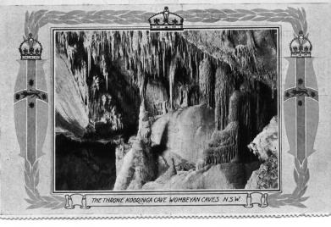 | Pu N.S.W. Government Tourist Bureau  F View enclosed in broad ornamental frame with floral decoration; printed on heavy  card with perforation along longer edge (formerly in booklet?); title is superimposed on view. (design comparable to Jenolan 56C, Yarrangobilly 5B)

5.1 The Petticoat, Junction Cave,/Wombeyan Caves. V
5.2 The Throne, Kooringa Cave, Wombeyan Caves, N.S.W. H
5.3 The Grotto or Enchanted Grove, Enchanted Corrridor,
Wombeyan Caves, N.S.W. H
5.4 Lot's Wife &/the Cockatoo/Wombeyan Caves/N.S.W. V
This is s.n.a. the illustration on p. 303 of Johnson et al., 1911.
5.5 Judgment Seat. Fig Tree Cave./Wombeyan Caves V

6. KERRY UN-NUMBERED CARDS [n.l. 1913]

Ph Charles Kerry
Pu Kerry & Co.
Pr in Germany by Collotype
F Title and Kerry imprint printed in sepia on white strip along bottom of card ; back
as Jenolan 4C

6.1 Museum, Korringa(sic) Cave, Wombeyan H (s.n.a. 1.1) [pm.30 Apr.1913]
6.2 Royal Bath, Wollondilly Cave, Wombeyan H (s.n.a. 1.2)
6.3 Mermaid’s Home, Wollondilly Cave, Wombeyan H
6.4 Entrance, Wombeyan Caves H (s.n.a. 1.4) [pm.9 Sep.1913]
  - The Sentinel, Fig Tree Cave, Wombeyan V (s.n.a. 1.5)
  - Lot’s Wife, Wollondilly Cave, Wombeyan V (s.n.a. 1.6)
  - Mantel Drape, Kooringa Cave, Wombeyan (s.n.a. 1.7) V
6.10 Jacobs Ladder, Junction Cave, Wombeyan (s.n.a. 1.10) V
6.11 Fairies Grotto, Woolondilly (sic) Cave, (s.n.a. 1.11) Wombeyan H
  - Long Corridor, Woolondilly (sic) Cave, Wombeyan (s.n.a. 1.12) H
[pm.28 Jan.1913]

7. VALENTINE'S GENUINE PHOTOGRAPH SERIES

Pu Valentine's Publishing Co.
F Photogravure card with title in white strip at bottom
of picture and white margin all around

7.1 The Grotto, Wombeyan Caves/N.S.W. V V10

8. BINNS SERIES

Ph & Pu H. Binns, Mittagong
F Full-frame collotype with superimposed title in red

8.1 Wombeyan Caves Road V (depicts road tunnel)

9. TRICKETT REAL PHOTO SERIES

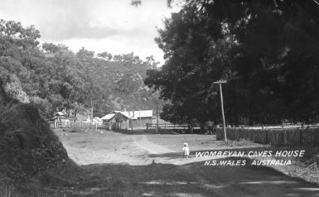 | Ph Oliver Trickett  F Full-frame real photo with title superimposed in capitals (Italics in 9.7, 9.8, 9.9 ; Roman in others)

  - The Grand Stalagmite/The Tree Cavern, Wombeyan Caves/ N.S. Wales,
Australia H K-D
9.2 Victoria Arch, Wombeyan Caves,/N.S. Wales, Australia V K-D
9.3 The Shawl, Junction Cave, Wombeyan Caves/N.S. Wales, Australia H K-D
9.4 The Petticoat,/Junction Cave,/Wombeyan Caves,/N.S. Wales, Australia H K-D
9.5 The Rapids, Junction Cave/Wombeyan Caves, N.S. Wales, Australia V K-D
9.6 The Basin's Cave/Wombeyan Caves/N.S. Wales, Australia V K-D
  - The Enchanted Groves,/Junction Cave, Wombeyan Caves/N.S. Wales,
Australia H K-D
9.8 Wombeyan Caves House/N.S. Wales, Australia H (view from entry road) K-D
  - Wombeyan Caves House/N.S. Wales, Australia H (view from
overlooking hill) K-D

- Valentine Series

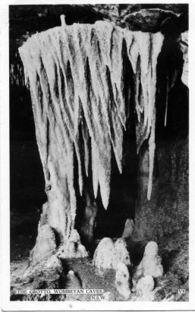 | Only one of the cards that we have is on the Valentine back (V10), but the remainder are of exactly the same format, several of them with the V number on the card so we assume all are by Valentine. Those which have the number shown on the card are identified below by the inclusion of the letter V in our numbering.

10.V3 Victoria Arch, North Entrance/ Wombeyan Caves, N.S.W. V Blank
10.V5 The Grotto, Wombeyan Caves/ N.S.W. V V10
SAME (ms. 1972) K-H
10.V7 The Fortifications, Wollondilly Cave/ Wombeyan Caves, N.S.W. H Blank 10.V11 Junction Chamber, Junction Cave/ Wombeyan Caves, N.S.W. H Blank
10.V13 Lot’s Wife and Cockatoo, Wollondilly Cave/Wombeyan Caves, N.S.W. V
(ms.27.i.65) K-?
10.?? Chalker Blanket, Junction Cave/ Wombeyan Caves, N.S.W. V Blank

Series nos 11-14 not used at this time.
Then I have only a very few of the post-1950s colour photographic cards:

15. Murray Views

15A.1 Wombeyan Caves / Victoria Arch V
With Green border and superimposed title

With Caves Reserve Trust logo at lower RH; title on back
15B.1 Kooringa Cave/ V
15B.2 Fig Tree Cave / Grand Stalagmites H
15B.3 Wollondilly Cave V
15B.4 Junction Cave / Chalker’s Blanket V

- Garrick Press

F Deckle edge

  - Lot’s Wife and Cockatoo in the Wombeyan/ Caves/ Southern Highlands,
N.S.W. V
  - The Rice Fields or Fortifications/ Wombeyan Caves/ Southern Highlands,
N.S.W. H
  - Colandes (sic) in the Wombeyan Caves,/Southern Highlands, N.S.W. V

- Goodwill Products

  - “Lot’s Wife” in Wollondilly Cave/at Wombeyan Caves, N.S.W. H

- Scancolor

18.1 Three images on a single card: Chalker’s Blanket in the Junction Cave, Wollondilly River, Road Tunnel

- Australian Collectors Choice

  - Mares Forest Creek H

Finally, there are the cards that cannot be assigned to any photographer or publisher:

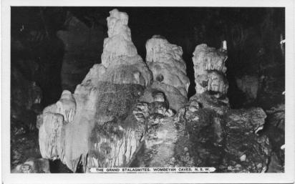 | May be by Hurley  The Grand Stalagmites, Wombeyan Caves, N.S.W. H on K-D  The Grotto, Wombeyan Caves N.S.W. V  On K-D ?  Lot’s Wife and the Cockatoo, Wombeyan Caves, N.S.W. V on K-D
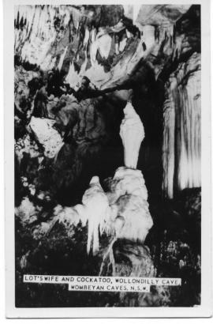 | Only card seen in this format  On blank back with ms.1972
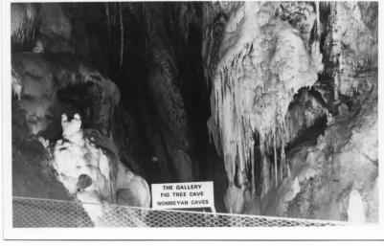 | Only card seen in this format  On blank back, ms. 1972.

